Rittal and Eplan at Hannover Messe
31 March to 04 April 2025
Hall 11, Booth E06
Rittal ecosystem with RiLineX technology partners
Power distribution – faster together
Herborn, 02 April 2025
When it comes to converting energy systems, power distribution and control technology is a key element. Companies that can manufacture and deliver this technology quickly, despite the skills shortage, have an opportunity for growth. To support its customers in this, Rittal has initiated a technology partner ecosystem with the launch of its RiLineX power distribution platform covering a wide range of AC and DC components from the outset.

Our customers need more and more speed, combined with a high level of flexibility – and that need is something many different applications have in common,” says Raphael Görner, Executive Vice President of Energy & Power Solutions at Rittal. “We therefore need to look beyond our own development processes. To achieve speed through standardisation and wide-ranging innovations, collaboration between companies is a must.That’s why, right from the start, Rittal designed its new platform as an open ecosystem that would enable innovative manufacturers to develop and sell “Ready for RiLineX” components that can be connected directly to the 60 mm busbar system.

K’ELECTRIC
K’ELECTRIC, which is based in the German city of Bayreuth, develops and sells switch-disconnectors, lightning and surge protection, and digital measurement technology, which is primarily used in AC environments. “We’re a smaller supplier – and we make a point of turning that to our advantage. We can work closely with our customers and partners and build their ideas and suggestions into our developments faster – and that applies for Rittal, too,” says Philipp Stöcklein, who is the key account manager for technical building equipment and energy suppliers at K’ELECTRIC. The result is exceptionally compact components for the high packing densities of modern systems – components that can now be installed on the board faster than ever thanks to the new contact design.

E-T-A Elektrotechnische Apparate GmbH
Direct current is not only distributed in battery storage systems and photovoltaic installations. In more and more industrial applications, power reaches the machine via stable direct current networks. As a global market leader in circuit protection devices and overcurrent protection, E-T-A Electrotechnical Apparatus GmbH, a protection equipment specialist based in Altdorf in Germany – brings many years of experience in direct current to the ecosystem. “In terms of switchgear and components, DC systems have different needs, in relation to arc quenching, for instance,” explains Richard Mehl, Head of Division Communication & Systems at E-T-A. E-T-A provides protection for expensive equipment in the mechanical engineering sector and process industry – in the form of either conventional electromechanical solutions or smart, selective protection systems.

EFEN
The specialist in safety and communication interfaces, provides intelligent and safe solutions for modern power distribution systems worldwide, with a strong focus on quality, service, reliability and sustainability. As a medium-sized company, EFEN is able to respond quickly to market demands. EFEN brings to the RiLineX ecosystem its extensive expertise in switchgear with fuses to DIN/EN standards. Harald Kownatzky, European Sales Manager at EFEN, emphasises: "Our cooperation with Rittal allows us to optimally complement our expertise and offer innovative solutions for power distribution.

The pace of power distribution continues to increase, as seen from the wide range of components available at the sales launch. The “Click & Work” platform of RiLineX enables users to be up to 30 percent faster in planning and designing and as much as 75 percent quicker at assembly. The next step involves components that directly contact the rails just as quickly and easily. Rittal and its partners also expect a snowball effect due to the high international distribution of RiLineX. “The suggestions from the Eplan Data Portal and the RiPower configuration software make it easier for planners and designers to discover the benefits of intelligent components, even though they may not yet be widely adopted in their markets,” Mr. Görner predicts.

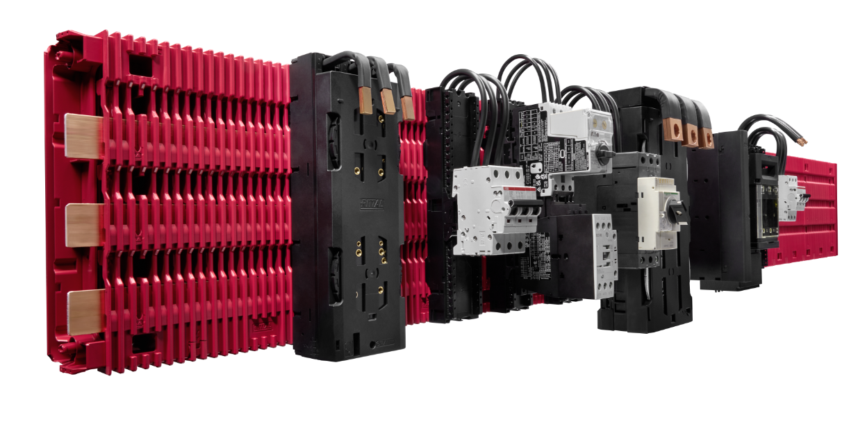 | 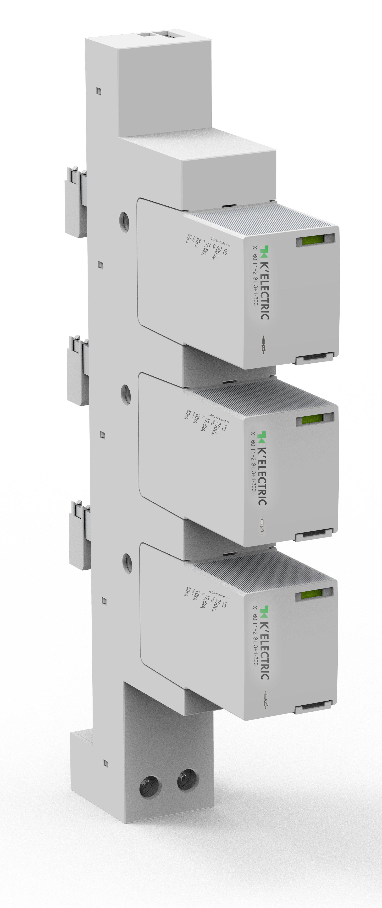 | 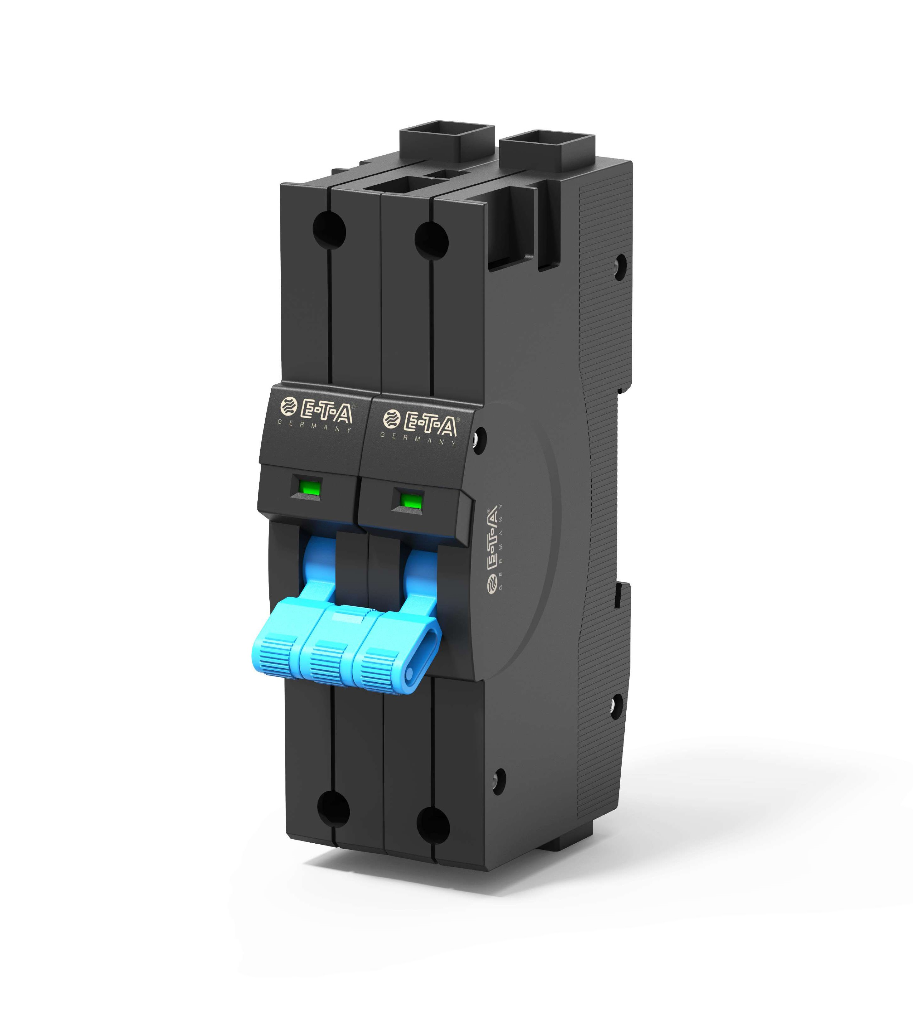 | 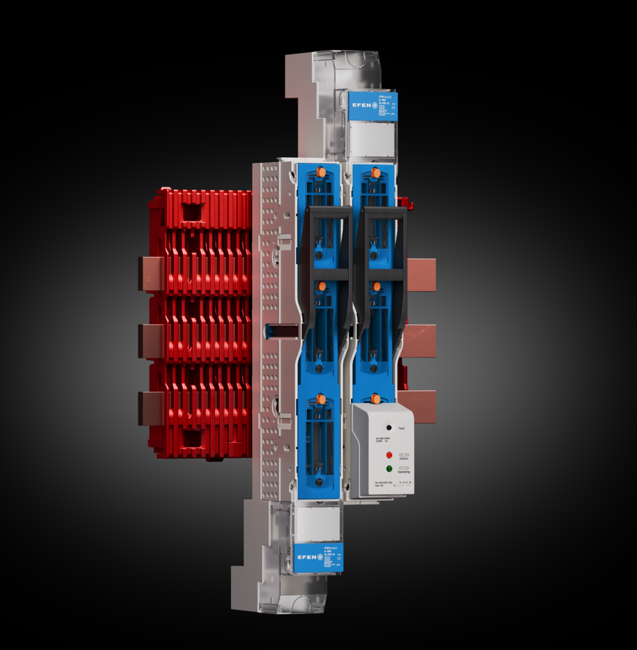
Image 1  To assist its customers, Rittal has launched the RiLineX power distribution platform, an ecosystem of technology partners that covers a wide range of AC and DC components, from the initial sales stage onwards. | Image 2  K'ELECTRIC surge protection for RiLineX and standard 60mm system – XT60 T1+2-SI, 3+1-300 | Image 3  The 8365-T hydraulic magnetic circuit breaker from E-T-A, which is suitable for RiLineX, is the first device in the world to be used for protecting consumers in HV DC networks up to DC 800 V. It combines high power density and space savings with a low power loss at only 19 mm wide. | Image 4  Ready for RiLineX: E³ NH slimline fuse-switch disconnector size 00/60 by EFEN

May be reproduced free of charge. Please name as the source: 1) Rittal GmbH & Co. KG, 2) K’ELECTRIC, 3) E-T-A Elektrotechnische Apparate GmbH, 4) EFEN GmbH

Rittal

Rittal is a leading global supplier of enclosure systems, automation and infrastructure with its industrial, IT, energy and power, cooling and service units. Rittal products and solutions are used in over 90% of global industries – standardised, customised, and always of the very best quality.
Our approach and methodology: Rittal, Rittal Software Systems (Eplan, Cideon) and Rittal Automation Systems (RAS, Ehrt, Alfra) combine their hardware and software expertise to streamline, optimise and digitalise processes across the entire value chain for our customers including their IT infrastructure – from control and switchgear construction, machine building to factory operators or the energy sector.
Our delivery promise: Rittal standard products are delivered in Germany within 24 hours, and within 48 hours throughout Europe.
Customer focus
Improving efficiency and increasing productivity through automation and digitalisation is one of the biggest challenges for our customers. This requires in-depth knowledge and expertise, the combination of hardware and software, and cross-sector networking. We are convinced that creating and connecting data rooms is crucial to the success of industrial transformation. And that is exactly our speciality and field of competence.
Eplan and Rittal are driving the development of the digital automation twin, making data accessible and useable in operations as well. Cideon is improving data consistency in the digital product twin context with its CAD/CAM, PDM/PLM and product configuration expertise.
Sustainability
Environmental and climate protection, social commitment and ethical corporate management are a given for Rittal. We take our responsibility for a sustainable future seriously. Our approach to resource management and conservation involves continuous improvement of our own production processes and ensuring that our products have the lowest possible Product Carbon Footprint. Our solutions support our customers in achieving their own climate targets.
Family business and global player
Founded in 1961, Rittal is the largest company in the owner-operated Friedhelm Loh Group. The group operates worldwide, with 12 production sites and 95 international subsidiaries. It has 12,100 employees and posted revenues of 3 billion euros in fiscal 2023. In 2023, the Friedhelm Loh Group was presented with the “Best Place to Learn” and “Employer of the Future” awards. In 2024, Rittal was awarded the Top 100 Seal as one of Germany’s most innovative medium-sized companies for the third time in a row.

For more information, visit www.rittal.com and www.friedhelm-loh-group.com.

Corporate Communications
Dr. Carola Hilbrand Rittal GmbH & Co. KG
Corporate & Brand Communications Auf dem Stützelberg
Phone: +49 (0)2772/ 505- 2527 35745 Herborn, Germany
hilbrand.c@rittal.de www.rittal.com

